"
S O U T H W E S T R E S E A C H I N S T I T U T E
622O ClULEBRA ROAD· POSTOFFICE'. DRAWER 26510 • SAN ANTONIO, TEXAS, USA 7922a·051Q • (512) 664-5111 • TELEX 244840
CHEMISTRY AND CHEMICAL ENGINEERING DIVISION DEPARTMENT OF FIRE TECHNOLOGY FAX (512) 522-3.'377
February 7, 1992
Flame Safe Chemical Corporation 2653 Warfield Avenue
Fort Worth, Texas 76106
Attn: Hr. Louis Jacobini
Re: SwRI Project No. 01-4510-159 FINAL REPORT
Small Scale Fire Resistance Test in Accordance with Section 1237.1 of Title 19 - Public Safety, of the Hea1th and Safety Code, regulations from the California Administrative Code
(12-Second Vertical Bunsen Burner Test)
Gentlemen:
This letter constitutes our final report on your blue/white striped 100% cotton mattress ticking with Fabric Safe flame retardant sprayed at a spread rate of 300 to 350 sq.ft/gallon, submitted for evaluation by the referenced test method. The fabric was tested as received. No water extraction or accelerated weathering was performed.
The results apply specifically to the specimens tested, in the manner tested, and not to the entire production of these or similar materials, nor to the performance when used in combination with other materials. All test data are on file and are available for review by authorized persons.
TEST METHOD AND PROCEDURE
The material was tested in accordance with Section 1237.1 of Title 19 ~ Public Safety, of the Health and Safety Code, regulations from the California Administrative Code. This is a 12-seconds vertical Bunsen Burner test that establishes afterflame time and char length on each specimen.
The specimens were conditioned for a minimum of 1 hour and no more than 1.5 hours at 140°F' prior to testing. Each specimen was inserted into the cabinet and the 1-1/2-in. (3D.1-mm) Bunsen burner flame (approximately 1650⁰P) was applied vertically at the middle of the lower edge of the specimen for 12 seconds.
The afterflame time of the specimen was recorded to the nearest
0.1 seconds and the char length to the nearest 0.1 in. (2.5 mm). The test criteria for this test are specified in Section 1237 of the above referenced document, as follows:
Char Length:
Char Length:
Afterflame :
Maximum average, 3.5 in.
Maximum, individual specimen, 6.0 in. Maximum, individual specimen, 2 seconds
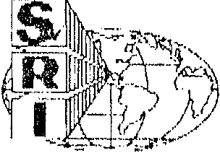

.

SAN ANTONIO, TEXAS

Flame Ssfe Chemical Corporation SwRI Project No. 01-4510-159
February 7, 1992
Page 2
Section 1237.1 12-sec. Vertical Bunsen Burner Test
TEST SPSCIKEN AND NUMBER OF DETERMINATIONS
The specimens were described as 100% cotton mattress ticking with Fabric Safe flame retardant sprayed at a spread rate of 300 to 350 sq.ft/gallon.
Each specimen was 3.0 x 12.5 in. (76.2 x 317.5 mm), nominal thickness 0.023 in. (0.584 mm). A minimum of three specimens were tested in each the machine direction (warp) and the across-machine directions (filling). The fabric was tested as received. No water extraction or accelerated weathering was performed.
TEST RESULTS
The test was conducted December 20 and 30, 1992 with the following results:
Machine Direction:
Run 1
Run 2
2.75 o
Run 3
2.63
0
,
Run 3
2.75
0
Average
Char Length, in. Afterflame, sec.
4.00 o
3.38 o
3.34 o
Run 1
Run 2
Average
Char Length, in. Afterflame, sec.
3.75 o
3.08 o
The material, when tested in the “as received" condition (no accelerated weathering or water extraction) in accordance with Section 1237.1 of Section 1237.1 of Title 19 - Public Safety, of the Health and Safety Code, regulations from the California Administrative Code (12-Second Vertical Bunsen Burner Test), is considered to have passed.
If you should have any questions/comments or if we can be of further assistance, please contact us.
Sincerely,
Approved by:

~ .. ~ \f\. v& if\tu.t. Cladys M. Finley G Project Leader
Fire Testing Services
Alex B. Wenzel Director
Department of Fire Technology
GMF/rr
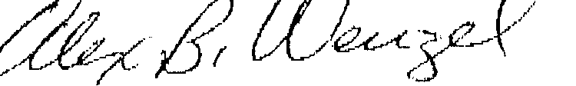


HOUST ON, TEXAS, • OETROIT, MICHIGAN· WAGHINC;TON, DC

