WASHINGTON, DC
S O U T H W E S T R ES E A R C H
I N S T I T U T E
6220CULEBRAROAD. POSTOFFICEDRAWER28510 • SANANTONIO,TEXAS,USA78228-0510 • (512)684-5111· TELEX244846
CHEMISTRY AND CHEMICAL ENGINEERING DIVISION DEPARTMENT OF FIRE TECHNOLOGY FAX (512) 522-33n
June 14, 1991
Flame Safe Chemical Corporation 2653 Warfield Avenue
Fort Worth, Texas 76106
Attn: Mr. Louis Jacobini
Re:
SwRI Project No. 01-3779-388 "Test for Surface Flammability Source (ASTM E162-90)"
FINAL REPORT
of Materials Using a Radiant Energy
Gentlemen:
This letter constitutes our final report on a fire retardant treated cardboard identified as "Flame Safe - Paper Safe", submitted for evaluation by the referenced test method.
The results apply specifically to the specimens tested, in the manner tested, and not to the entire production of these or similar materials, nor to the performance when used in combination with other materials. All test data are on file and are available for review by authorized persons.
TEST OBJECTIVE AND PROCEDURE
The procedures followed in this test cover the Surface Flammability of Materials as outlined in the standard test procedure. They shall be used solely to define the properties of materials in response to heat and flames under controlled laboratory conditions. The results shall not be used as measures of fire hazards under actual fire conditions, but only for research and development purposes. The test defines the ignition properties and the rate of heat release which are combined to provide a Flame Spread Index.
Test specimens are preconditioned at 140°F (60°C) for 24 hours followed by stabilization at 70°F (21°C) and 50-percent relative humidity. The 6 x 18in. (0.15 x 0.46-m) specimen is affixed in a metal frame and the assembly is placed in front of the 12 x 19-in. (0.31 x 0.48-m) radiant panel at an inclined angle (30⁰)--being closer, 4.75 in. (0.12 m), at top. A 2- to 3-in. pilot flame impinges on the uppermost area of the specimen and flame propagation advances downward on the specimen. Observations such as dripping, cracking, delamination and distortion are noted and recorded. The Flame Propagation Factor (Fs), Heat Release Factor (Q) and Flame Spread Index (Is) are calculated using incremental flame front propagation rates and predetermined radiant panel characterization formulae (Is = Fs x Q).
,.,

This reoort is lor the Information of Ihe client. 11 may be used In Its enlir9fy tor the purpose 01 securing product acceptance from duly constnuted awrovaJ authorities. Neither Ihis repon nor the name of Ihe Institute shall be used in pLtJlicfty or advenising.
SAN ANTONIO, TEXAS
HOUSTON. TEXAS • DETROIT, MICHIGAN •
~


Flame Safe Chemical Corporation SwRI Project No. 01-3779-388
June 14, 1991
Page 2
MATERIAL DESCRIPTION
Date Received:
Type:
Identification:
Color:
Nominal Thickness:
Nominal Unit Weight:
ASTM E162-90 Test Method
June 7, 1991
Fire retardant treated cardboard Flame Safe - Paper Safe
Brown cardboard/clear coating 0.17 in. (4.32 mm)
0.208 lb/ft² (1016 g/m²)
PREPARATION AND CONDITIONING
Preparation:
Conditioning Time:
TEST DATA
Date of Test:
Mounting Procedure:
Specimens Tested:
None other than conditioning required
5 days, 70°F and 50% relative humidity
June 13, 1991
The specimen was removed from the conditioning chamber and mounted in the specimen holder with a 6 x 18-in. (0.15 x 0.46-mm) sheet of 1-in. (25-mm) hexagonal 20 AWG wire mesh placed against the face of the specimen. A sheet of 0.25-in. (6.35-mm) inorganic cement board, wrapped around the back and edges with aluminum foil with the bright side facing the specimen, was used to back the specimen. A retaining rod was used to secure the specimen in place.

4
All data remains on file and is available to authorized personnel.
CALIBRATION CONSTANTS
Maximum stack temperature, °F (°C)
C (arbitrary constant)
Beta Factor (°C/kW)
456.0 (235.6) 5.7
27.15

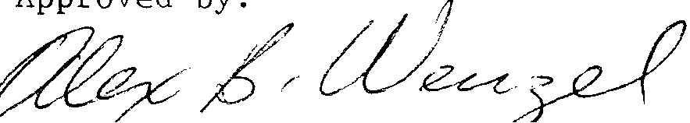
Flame Safe Chemical Corporation SwRI Project No. 01-3779-388 June 14, 1991
Page 3
TEST RESULTS
Fs = Flame Spread Factor
Q = Heat Evolution Factor
Is = Flame Spread Index
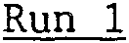
Fs
2.9 1.4
4.1
Q
Is
OBSERVATIONS
ASTM E162-90 Test Method
Sincerely,
~
Gladys M. Finley Research Engineer Fire Testing Services
GMF/rr
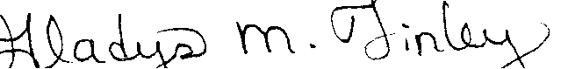
Run 2 | Run 3 | Run 4  Run 4 | Average
3.1 | 2.4 | 6.5 | 3.7
1.4 | 1.3 | 1.3 | 1.4
4.3 | 3.1 | 8.5 | 5.0
Approved by:

Department of Fire Technology for
Alex B. Wenzel,
Dr. Robert E. Lyle
Vice President, Chemistry and Chemical Engineering
No flaming drip or running was observed. Cracks were noticed on the specimen face. Small nonflaming particles fell onto the floor. Specimen charred to the 12-in. mark.

